PSSI Science Project Reporting Template

️ | The PSSI Implementation Team is compiling a technical report to demonstrate the important research and advancements made by the Science Branch through the PSSI funding. The technical report will include a 3-4 page summary (including graphics and figures) for each project to show their key results and findings. Please fill in the following fields and sections for your project to be included in the report. Feel free to include and draw from any reports or presentations previously created through your research.  A plain language science bulletin will also be created to follow up on last year’s “DFO Pacific Region Science Bulletin, 2024. New research and monitoring for Pacific salmon and their ecosystems.” While the first bulletin introduced project backgrounds, methods, and timelines, this new bulletin will highlight the projects’ results, key findings, and conclusions with links to reports and data available. The bulletin will include a 1-2 page summary for each project gleaned from the content entered below.  ️ Completed forms are due January 7, 2026.  *Please include or send separately any graphics or pictures (with photo credits) that will help promote the projects.

PART 1: PROJECT METADATA

General Project Information
Project ID (number) | Project Title
2430 | Feasibility of Estimating Chilko River Smolt Abundance Using Upward- and Side-Looking SONAR Methods
Project Leads | Collaborations and External Partners
Daniel Doutaz | Aquacoustics Inc.  Tŝilhqot'in National Government (TNG)
Location (if applicable) | Aquacoustics Inc.  Tŝilhqot'in National Government (TNG)
Click or tap here to enter text. | Aquacoustics Inc.  Tŝilhqot'in National Government (TNG)

Geographic and Stock Information
Salmon species (if applicable) | Waterbodies (if applicable)
Sockeye Salmon | Chilko River
Life history phases (if applicable) | Region
Juvenile (smolt stage) | Pacific (Fraser River)
Stock (if applicable) | Population (if applicable)
Chilko ES/S CU | Click or tap here to enter text.
Conservation Unit (if applicable)
CU 3 (Chilko-ES); CU 4 (Chilko-S)

🧰 PART 2: PROJECT METRICS

Project Outputs
Include any anticipated outputs denoted as (in progress). Please include links to any outputs available online so they can be referenced in the report.
List scientific publications and technical reports (with links)
- SONAR-Based Estimate of 2025 Chilko River Sockeye Smolt Abundance (in progress)
- SONAR-Based Estimate of 2024 Chilko River Sockeye Smolt Abundance
- SONAR-Based Estimate of 2023 Chilko River Sockeye Smolt Abundance
- SONAR-Based Estimate of 2022 Chilko River Sockeye Smolt Abundance
List datasets generated (with links)
A combination of Excel spreadsheets and SONAR files (Simrad echograms) were generated for each year of operations (2022-2025).
Describe dataset locations and data management systems
Data stored on external hard drives, archived at Kamloops DFO office.
List code, programs, or other software created (with links)
N/A
List communication or social media products
N/A
List and describe field work completed
Deployed and operated up- and side-looking SONAR units in Chilko River to enumerate sockeye smolts outmigrating from Chilko Lake (2022-2025).
List and describe samples collected/analyzed (number of samples)
N/A
List and describe large capital assets or equipment acquired
N/A

PART 3: WRITTEN CONTENT

Highlights
Please summarize in 2-3 bullets:
- The main idea of the project
- Key findings
- Implications of these findings for salmon and decision-makers
- For a more technical audience, but still as plain language as possible
- The main goal of the project was to test the use of SONAR technology to enumerate Sockeye salmon smolt outmigration, while concurrently running a counting fence to evaluate its performance over a four year period.
- Over the course of three years (2025 results are pending), the total number of Sockeye smolts estimated with SONAR when compared to estimates generated at the enumeration fence, ranged from 5-33% (5% in 2024, 8% in 2023, 33% in 2022).
- This method has been shown to be effective at enumerating Sockeye smolts, which is an important and often lacking piece of information in salmon stock assessments (e.g. estimating early freshwater survival, generating stock-recruit relationships). However, using SONAR in this configuration is highly dependent on site selection, stream morphology, flow conditions, and the ability to adequately sample smolts for size measurements used in the analysis.

Background
Please provide 1-2 paragraphs to summarize
- The relevant biological, environmental, and/or management context
- What knowledge gap or demand were you trying to fill?
- Collaboration and partner relationships
Chilko Sockeye salmon represent the only wild Sockeye indicator stock in the Fraser watershed. The annual Chilko Lake Sockeye smolt assessment (1951-present) comprises the only long-term time series data available to assess juvenile recruitment, and freshwater and marine productivity for wild Fraser River Sockeye salmon. Since program inception, Sockeye smolts have been enumerated during their out-migration from Chilko Lake using a traditional fish counting weir and photographic sampling/counting techniques. During the first six decades of the program (1951-2012), interruptions in weir operation were relatively rare: in only three years (1979, 1993, 2006) did early freshets necessitate removal of the weir before the vast majority of smolts had migrated from Chilko Lake.

Recently, unusually early freshets have been experienced in the Chilko watershed that have translated into high and variable water conditions much earlier in the season. As such, DFO Stock Assessment crews were not able to operate the weir in 2015 due to high water flows, and have had to remove the weir structure prior to the completion of smolt migration on numerous other recent years (e.g., 2019). The observed increase in the frequency of early freshets in the Chilko watershed is consistent with predicted hydrographic changes for interior BC streams as a whole in response to climate variability, with the average timing of the spring freshet expected to continue shifting earlier as air temperatures rise. The future of operating the Chilko Sockeye smolt weir is in jeopardy given the current trend related to the timing, frequency, and strength of the spring freshets. If proven effective, the SONAR method would provide an alternate assessment method for the Chilko watershed that could be quickly employed in years when high flows either prevent the installation of the weir at the beginning of the migration, or necessitate the removal of the weir before the smolt migration is largely complete.

The objective of this work was:
- Test the feasibility of using upward-looking SONAR technology to assess daily abundances of Chilko Lake sockeye smolts as they migrate downstream through the Chilko River.
- Evaluate the reliability of using daily SONAR-derived abundance indices predict the daily migration totals observed at the counting weir that is deployed annually on the Chilko River.

This work was conducted in collaboration with the Tŝilhqot'in National Government (TNG).

️ Methods and Findings
Please insert a few paragraphs to summarize:
- Main methods used
- Products and tools produced
- Advancements in methodology, technology, and application
- Advancements in communication and knowledge transfer
- Key results and information generated
Acoustic data were collected with two Simrad WBT Mini SONAR systems deployed approximately 2 km downstream of the Chilko River smolt enumeration fence. Each SONAR system operated with a 7° circular 120 kHz split-beam transducer. For the up-looking system, the transducer was mounted on the river bottom, in the thalweg, aimed straight up towards the water surface. For the side-looking system, the transducer was mounted nearshore on the left bank of the river, with its center approximately 15 cm below the surface, aimed across the river with a transducer tilt angle of approximately 3° down from horizontal. Data were recorded with a ping rate of 20 pings per second on the up-looking (maximum range 4 m), 12 pings per s on the side-looking system (maximum range 12 m). Both systems were set to 50 W power output. For all four years of the study, SONAR data were collected from mid-April to late-May during the entire Chilko Sockeye smolt outmigration period.

SONAR data was manually reviewed and edited using Echoview software to remove noise, and echo integrated in 1 hour x 1 m range cells (side-looking) or 1 hour x 0.2 m range cells (up-looking). The results were exported as csv files, and all echo integration csv files belonging to the same transducer and site were concatenated for further analysis in Microsoft Excel. Excel was then used to convert the echo integration results to smolt passage estimates, which were then compared to the estimates generated at the Chilko River smolt enumeration fence.

In 2023 and 2024 (2025 results pending), daily estimates of smolt passage showed close correspondence (5% in 2023, 9% in 2024) between fence counts and independent acoustic estimates both in time and magnitude. In the first year of the study (2022), daily SONAR estimates were in good agreement with the fence counts over the first 9 days of the study, but consistently higher over the last 9 days (May 3rd and thereafter). At present, the source of this divergence is unclear.

This project is one of few that have used split-beam SONARs configured in this manner to enumerate outmigrating salmon smolts. While further testing needs to be conducted in both the Chilko River where the study was conducted, and in other candidate systems, the preliminary results of this study are promising. These methods could be modified and applied to a variety of salmon stock assessment programs to gain crucial information on survival in the early freshwater life stages (egg to smolt survival), however, considerable planning and care needs to be taken when selecting a suitable site.

Insights
Please insert a few paragraphs to summarize:
- What this project has added to knowledge about salmon populations, health, or ecosystems.
- How this project informs salmon management:
  - decisions
  - policy guidance
  - trade-offs
  - planning
- Addition of knowledge to understanding:
  - limiting factors/stressors/threats/ pathways of effects/risks
  - biologically significant thresholds
  - cumulative impacts
- Sources of uncertainty
This project has shown Sockeye salmon at the smolt life stage can be effectively enumerated using SONAR, and is an easily-deployed and operated alternative to installing large enumeration fences which are typically labor-intensive and may disturb stream substrates. Many salmon stocks are solely assessed through adult escapements, which does not capture survival during the early freshwater life stages, and creates additional challenges when investigating individual stock recruitment and forecasting returns that are used in fisheries management and planning.

Using SONAR to enumerate salmon at the smolt stage enables researchers to investigate survival metrics during the early freshwater period in which there is often little or no data at the population or Conservation Unit (CU) level. In systems where there is ongoing juvenile enumeration work (e.g. with counting fences, rotary screw traps (RST), incline plane traps (IPT), etc.), this method may provide a suitable, and less invasive alternative to conventional methods. Further to this, the observed increase in frequency of early freshets and hydrographic changes in response to climate variability may preclude the operation of some juvenile assessment methods, leading to the need for other means of collecting juvenile salmon data.

Sources of uncertainty raised from this project include discrepancies in SONAR counts when compared to fence counts (particularly in the 2022 study year), which at this time are unresolved. Additionally, there in uncertainty how the system deployed would operate under heavy flow conditions, in systems with different stream characteristics, and in systems with multiple species of Pacific salmon with overlapping outmigration timing.

⏩ Next Steps
Please insert 1-2 paragraphs to summarize:
- Remaining knowledge gaps and recommendations for future studies
- How can/should the project findings be operationalized for salmon conservation and management?
This work describes how split-beam SONAR systems can be deployed and configured to enumerate outmigrating salmon smolts, which can provide crucial information on egg to smolt survival, stock recruitment, and freshwater habitat conditions and quality. This additional information can then be used to inform management strategies or mitigations for stocks below conservation benchmarks, or inform enhancement work conducted by the DFO Salmonid Enhancement program where no metrics exist other than adult escapements to evaluate performance (e.g. Bowron, Pitt, Taseko rivers).

📈 Tables and Figures
Please provide captions and numbering for any tables and figures. Graphics can be copied below or e-mailed separately.
- Include a brief caption with each figure and table in the box below
- Number each table and figure, and include references in the above sections where appropriate.
- 1-3 figures are recommended per project
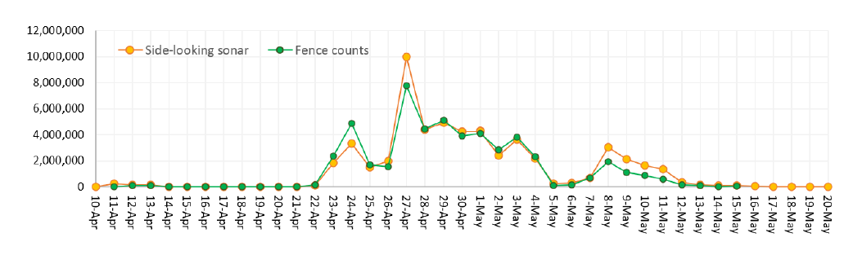
Figure 1. 2024 daily estimates of Chilko River Sockeye smolt passage: side-looking SONAR estimates versus fence counts.

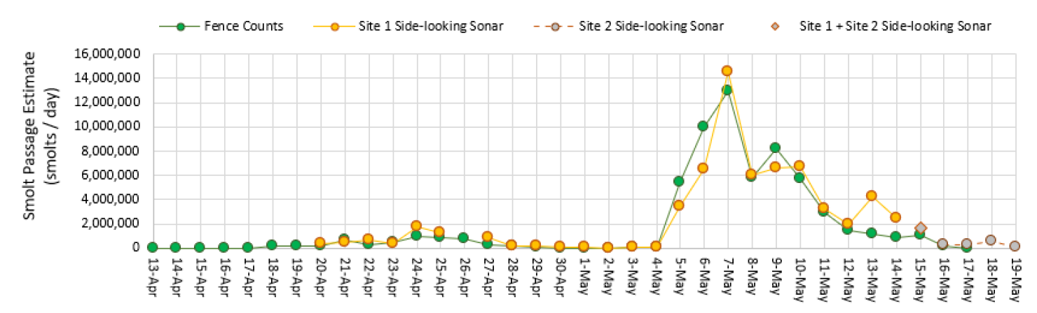
Figure 2. 2023 daily estimates of Chilko River Sockeye smolt passage: side-looking SONAR estimates versus fence counts.

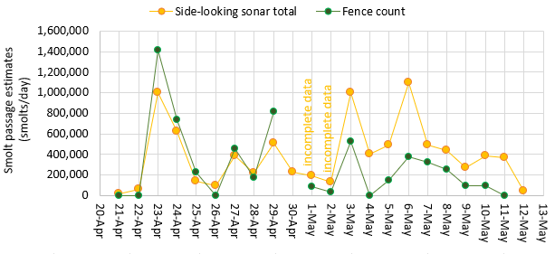
Figure 3. 2022 daily estimates of Chilko River Sockeye smolt passage: side-looking SONAR estimates versus fence counts.

📈 References
Include full references for any publications referenced in other sections. Please format references in Harvard style according to Instructions to Authors for the Canadian Journal of Fisheries and Aquatic Sciences, at Canadian Science Publishing.
Click or tap here to enter text.

